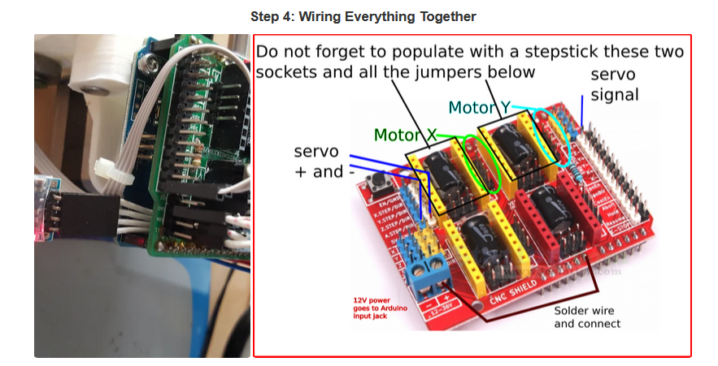
From file : https://www.instructables.com/4xiDraw/

Before inserting the CNCShield over the Arduino you want to do this trick, that will allow to power everything from the Arduino power jack. Failing to do this connection from Vin to + header on CNCShield most likely will make your servo not to work properly.
On top of Arduino you insert the CNCShield board and on top of it, two of the Pololu StepStick stepper driver boards. But before inserting these two boards for axis X and Y, make sure you put three jumpers in the headers (that will later be obstructed by the Pololu carrier boards).
A three-wire cable will be coming from the servo and two four-wire cables come from the stepper motors.
Servo cable has to go to (red) +5V, (black) GND and signal (white or brown) to Digital pin 11. Servo cable is too short, so an 250mm extension cable will be needed.
Each stepper motor goes to X and Y axis four pin headers on the CNCShield.
There is an optional improvement: make the plotter wireless by adding a Bluetooth module, but I would only do this once everything else is up and running.

From File : CNC-Shield-Guide-v1.0.pdf

Component Assembly

Below is a general outline process for connection of the various components:
1. Taking normal static electricity precautions, insert the CNC Shield into the Arduino Uno making sure the
correct pins of the CNC Shield are inserted into the correct UNO headers.
2. Decide on the micro stepper setting for your application and place the jumpers as required

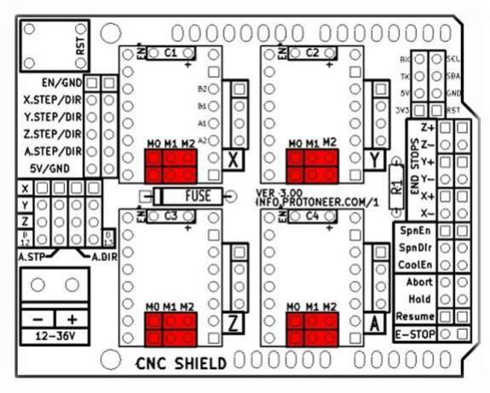

In the tables below High indicates that a Jumper is insert and Low indicates that no jumper is inserted.
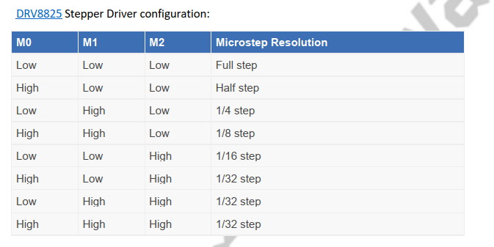

Push button connections

Cable colour | Button | Description
Black | E Stop | Arduino Reset
Green | Resume | Resume printing
Red | Hold | Hold printing
Blue | ABORT | Abort present printing
Orange | GND

From File : NEMA17-schneider.pdf

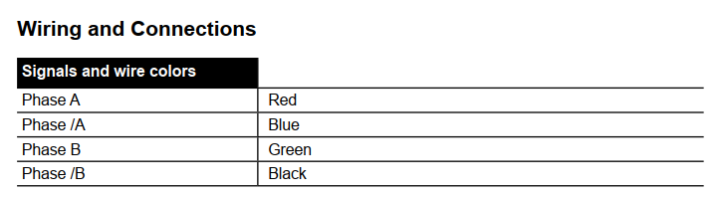

From File : 42SHD0001.jpeg

